**API/Postman Run book**

Contents

Prerequisite for running the API in postman 2

Configuring the postman 4

Import Postman collection 4

Authorization steps to GCP (Generate Access token) 4

Consuming the API to get the response 5

# Prerequisite for running the API in postman

1. Postman need to be installed
2. Enable the API Integration in “Search & Conversation” page in GCP.

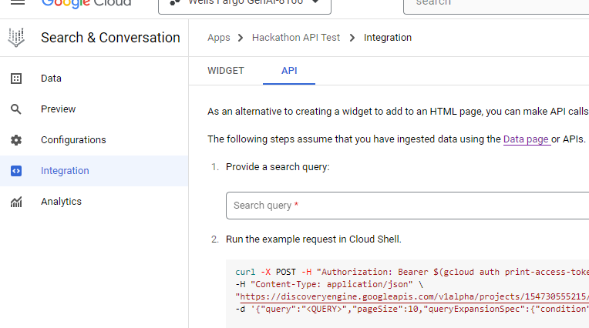

1. Enable the OAuth 2.0 in GCP as shown below.
   1. Go to 🡪 **APIs & Services** in GCP
   2. Go to 🡪 **Credentials** tab
   3. Click on **“+ Create credentials**” button
   4. Select “**OAuth client ID**”

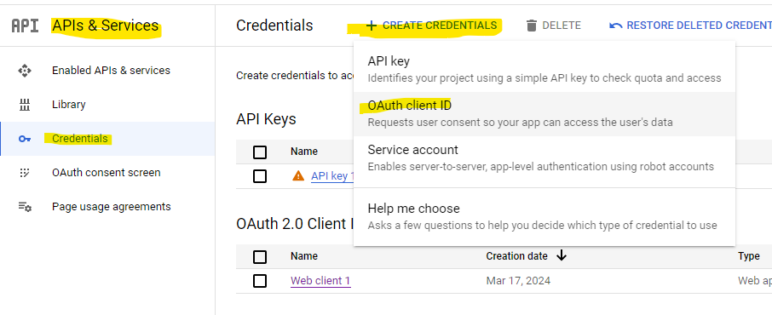

* 1. Select the Application Type as “**Web Application**”
  2. Specify a name to the access.
  3. On the Authorized redirect **URLs🡪 add the below 2 redirect URLs**. (This is used in further steps in postman to get the access token to query the API)
     1. <https://oauth.pstmn.io/v1/browser-callback>
     2. <https://oauth.pstmn.io/v1/callback>
  4. Then click on **create/save button to create the OAuth 2.0**.
  5. Once its created you will be able to see the **Client ID, Client secret** and other information as shown below.

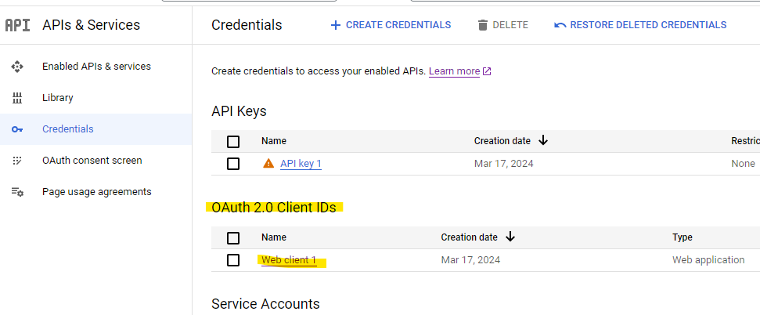

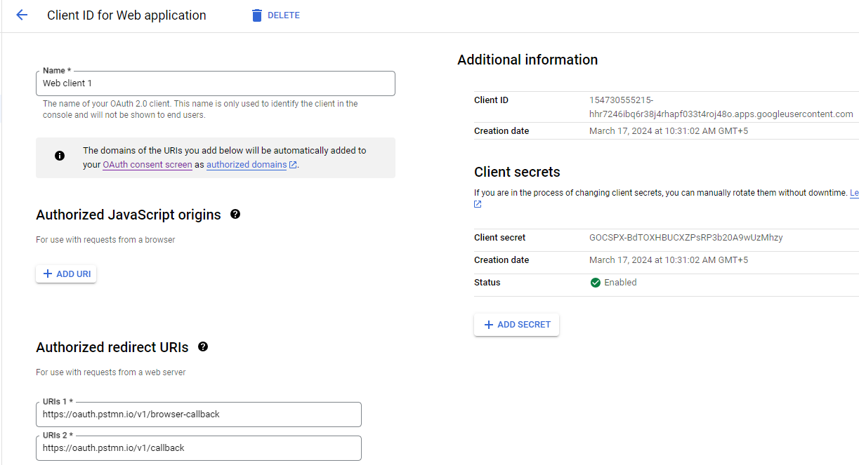

# Configuring the postman

### Import Postman collection

1. Import the below attached JSON config to postman



### Authorization steps to GCP (Generate Access token)

1. Open the above postman request
2. Go to Authorization tab 🡪 Configure new token section
   1. Enter the clientID, Client secret, scope and all other required info as shown below.

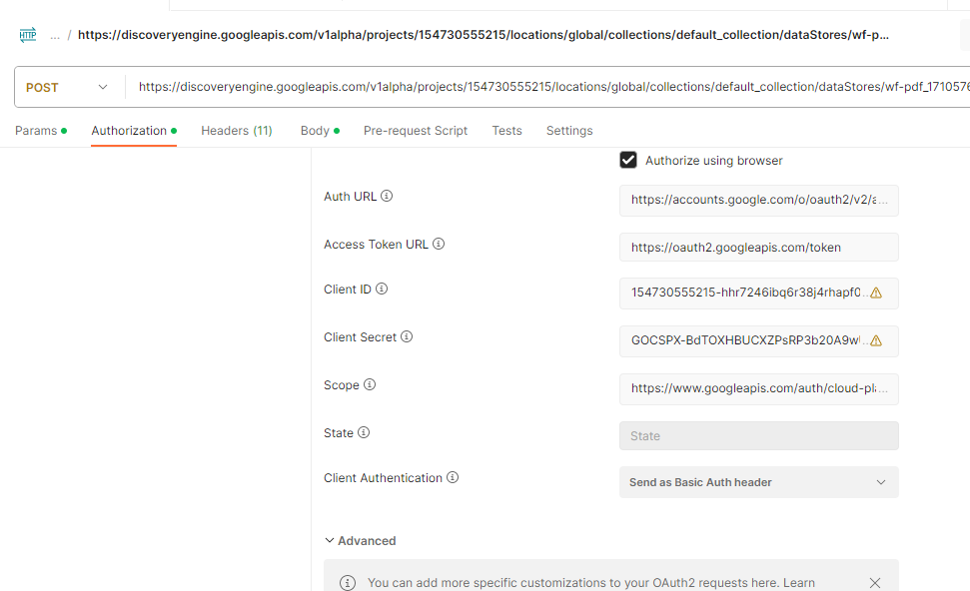

1. Then click on “Get New access token” button.
2. This will redirect to browser to provide the access to the GCP from the postman.
3. Once authenticated from browser it will show the bearer token, click on the “use token” to use the token generated in above step.

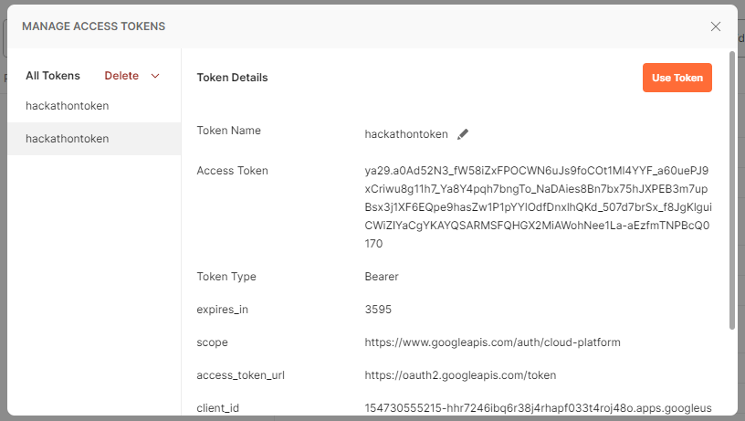

### Consuming the API to get the response

1. Go to 🡪 body section in the postman request and provide the question as shown below.
2. Click on the “Send” button to get the API Response.

